Student Name: Xianglong Lin Student Number: 45791439 Team Name: H2OMG
Week: _3_
Title: Method Selection in Water Resource Design
Description:
In the 3rd week, our team moved from initial brainstorming to a more focused exploration of water resource management within households. Building on the personas established in the 2nd week, we decided to use Interviews and Autoethnography as our primary research methods. These 2 approaches allow us to study water usage from both external and internal perspectives, providing a comprehensive view. Last week, we explored broader themes like household communication and water usage. However, we realised the need to focus specifically on water resource usage to develop measurable and feasible design solutions. Unlike the previous week, which centred on defining the project and personas, this week we concentrated on selecting research methods that best uncover user behaviours and personal experiences related to water usage. Interviews will help us gather insights into the social and cultural contexts influencing water usage, while Autoethnography will provide deeper, introspective reflections, complementing the data from interviews. This combination ensures a thorough approach to our project.
Visual Evidence:
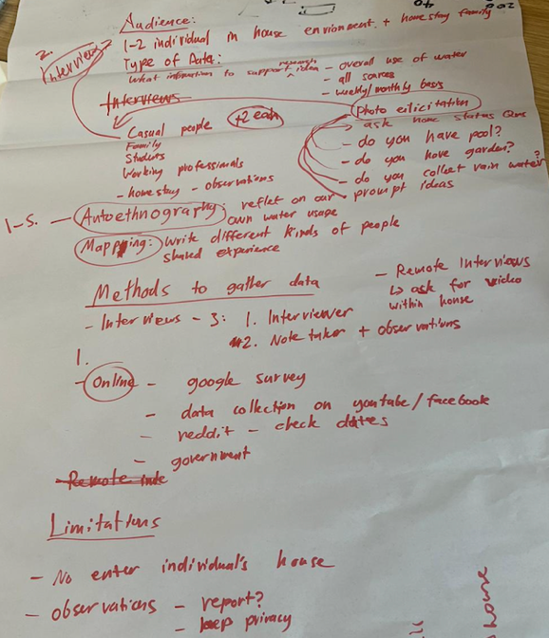
Statement on Learning:
This week’s studio taught me the importance of balancing different research methods to better capture user behaviors and experiences. Through Interviews, a wide range of perspectives will be captured, ensuring that the design solutions are grounded in the real experiences of different user groups. Autoethnography allowed me to critically reflect on my own interactions with water usage, bringing to light subconscious habits and preferences that might otherwise go unnoticed. The combination of these methods taught me that integrating external data collection with personal self-reflection can lead to more comprehensive and user-centred design outcomes. In summary, the method selection and planning this week undoubtedly lay the foundation for our team’s upcoming research activities. By leveraging both in-depth and accessible research methods, we will gain a more thorough understanding of the complexities of water resource usage within household environments, ultimately ensuring that our design solutions are effective and user-centred.

